Title Should Be Capitalized for Each Initial Letter

Author’s Name Surname,¹ Presenting Author’s Name,² Other Authors¹
¹Affiliations, Complete Address
²Affiliations, Complete Address
E-mail: name@saga-u.u.ac.jp

You can use this template (overwrite) to prepare your oral or poster abstract for VOA9 without changing font size, indent, justification, spacings and margins. The main text is written here with font style (Times New Roman or Times), font size (12 pt) and line spacing (normal). Do not exceed one page at A4 format.
Reference(s) within the text should be referred by square brackets using [1], [1, 2] or [3-5] for single, two, or more references, respectively. For the list of references use the format below.
Schemes and Figures should be inserted as in-line images, non-floating and in grey at a high quality. Continuous numbering is used if more than one Scheme or Figure is present.

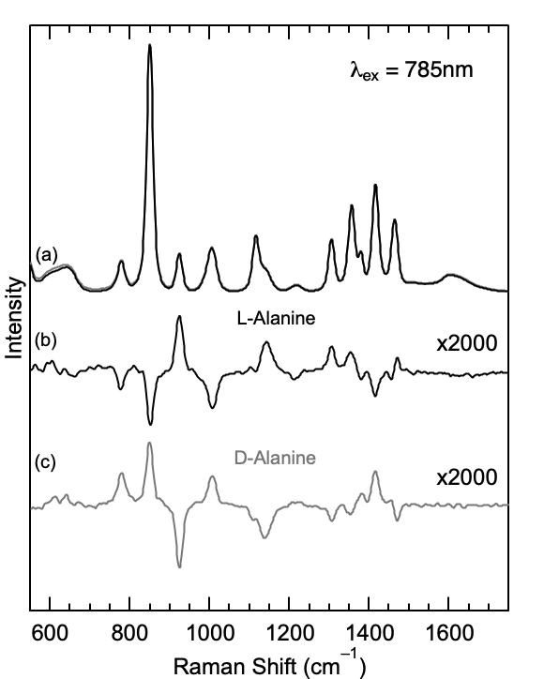

Figure 1. This is a style of figure caption. The font size is 12 pt. The figure is centered as shown above [6].

References
[1] First, A.; Second, B.; Third, C. J. VOA 2023, 138, 1.
[2] First, A.; Second, B.; Third, C. J. VOA 2023, 138, 10.

